Management Committee Member  School Visits |  |  | 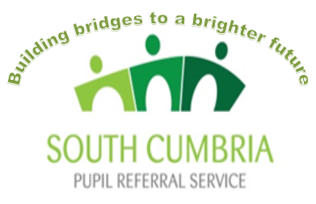  Building bridges to a brighter future  Building bridges to a brighter future  Building bridges to a brighter future
 |  |  | ISSUE 3
 |  |  | DATE: Sept 2023
RECORD OF ISSUE
ISSUE | DATE | SUMMARY
1 | 14/06/21 | 2021-2022 introduced from NGA training
2 | 02/11/22 | Retrospective policy review for new AY
3 | 13/10/23 | 2023-2024 Annual review

DOCUMENT CONTROL
This document is the property of South Cumbria Pupil Referral Service and is subject to controlled issue by: South Cumbria Pupil Referral Service
 | NAME | SIGNATURE | DATE
AUTHOR(S) | Leeann Evans | 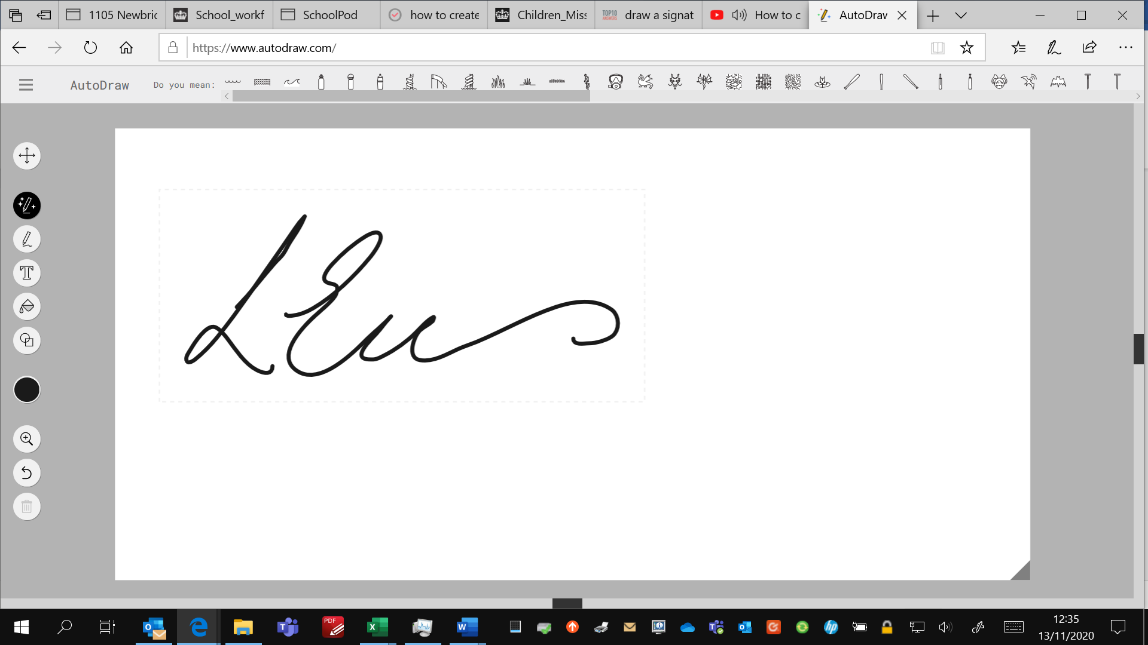 | 13/10/23
HEAD TEACHER | Lisa Balderstone | 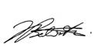 | 1/12/23

Policy aims

This policy aims to ensure that all members understand:
- the purpose of monitoring visits
- the expectations for carrying out visits including preparation, expected conduct and reporting back to the Management Committee

Purpose of visits carried out by Management Committee members

Visiting school on a planned, regular basis allows members to:
- better understand their school’s strengths and areas for development
- determine if agreed policies and procedures are working in practice
- identify how resources are being used
- show staff and pupils that they are interested in the life, work and achievements of a school
- experience the culture and ethos of the school

Monitoring visits should focus on:
- strategic priorities and key policies agreed by the Management Committee
- the evaluation of progress: are the things people say are happening actually happening?
- seeking assurance that the needs of pupils are being met (such as safeguarding and SEND)

Frequency of visits

The frequency of visits should be in accordance with the schedule established by the Management Committee and agreed with school leaders and relevant staff. Visits should be scheduled to allow the Management Committee to see relevant activities and strategic milestones.

Arranging and preparing for visits

Visits should be arranged through the headteacher, with adequate notice, and agreed with the relevant members of staﬀ.

Due regard should be given to:
- how the visit fits with the schedule of committee meetings, to allow for timely feedback and discussion
- how to avoid visits clashing with important events and/or busy periods in school life
- the workload implications for staff who are likely to be involved in the visits
- Members are encouraged to prepare for their visit. This may include:
- reading and familiarising yourself with the protocol for visits and the expected conduct
- reading and familiarising yourself with the school’s policy for visitors (this is different from this policy) that includes relevant health, safety and safeguarding instructions
- reading the background information relating to the focus of the visit, such as relevant section(s) of the School Development Plan, performance data, policies, stakeholder information
- clarifying the purpose of the visit with the head teacher and or relevant member of staff
- confirming the visit schedule and activities

Conduct on visits

When visiting the school in your capacity, you should:
- arrive in good time and follow the school’s procedures (such as signing in and producing identification)
- adopt a friendly approach that puts everyone at ease
- be respectful of the school at work and if you wish to take notes, check that those you are with are comfortable with this
- if you are taking notes, be clear with everyone that this is for feedback purposes and that you are not recording judgements (for example on the quality of their teaching)
- ask relevant questions that are closely linked to the purpose of your visit
- acknowledge the staff and pupils you meet
- Members are also expected to behave in line with the Management Committee code of conduct, being aware of the need to maintain confidentiality.

Expectations following a visit

A ‘record of visit’ (see appendix 1) should be completed as soon as possible after each visit. A draft will be shared with the headteacher and any other members of staﬀ involved in the visit and, when agreed, a final version will be included in the papers for discussion in the next Management Committee meeting (this may be the full meeting or a committee, as appropriate).

APPENDIX 1


Management Committee Member Visit

MONITORING AND EVALUATION SHEET
Upon completion of this form please return to the Clerk to the Committee.

Management Committee member(s) involved: |  | Date:
Staff member(s) involved:

Purpose of visit:

Summary of activities:

How does the task relate to the schools priorities?

What have I learned as a result of my visit and how will I feed this back to the Management Committee:

Discussion points for the Management Committee ____ / ____ / 20 ___

Please note any safeguarding practice(s) observed (positive or negative):

Actions from visit:

General feedback on centre: (Welcome, appearance, students/staff met, work seen e.t.c.)

SIGNED: | DATE:

