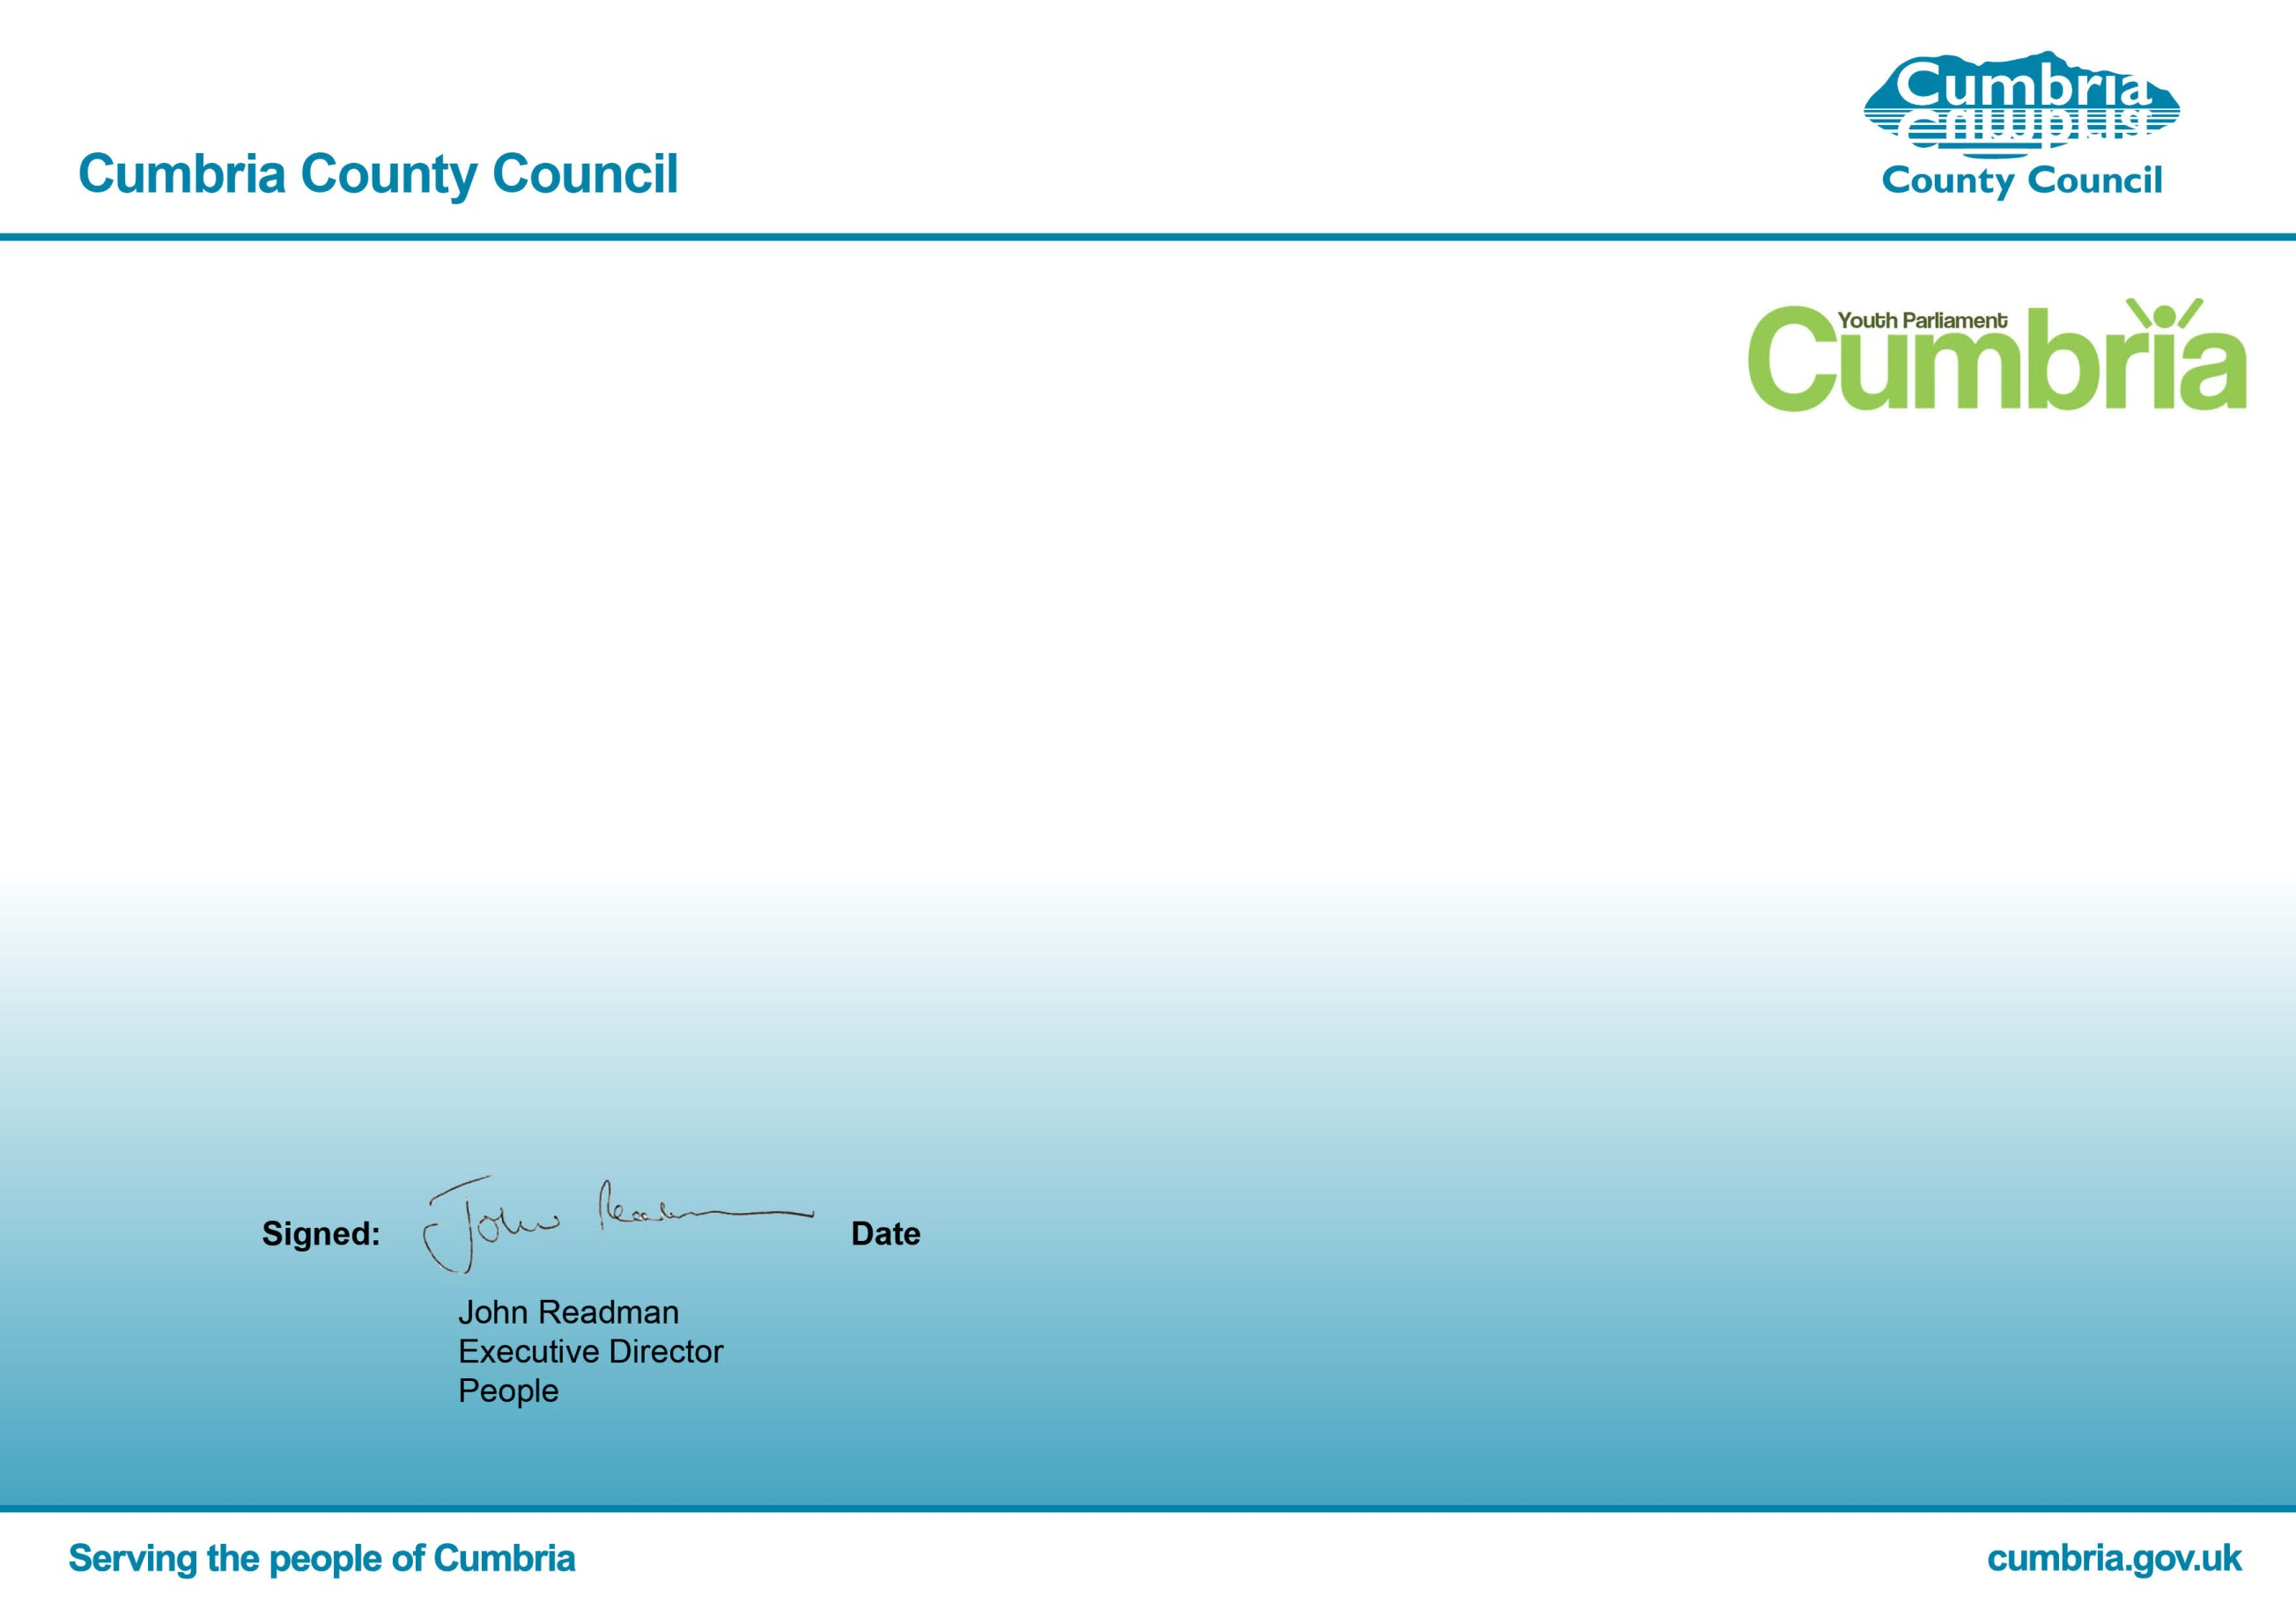
30/03/2020
A Democracy Award to thank you for your participation in the 2020 Cumbria UKYP Elections.
This certificate is awarded to

Newbridge House

