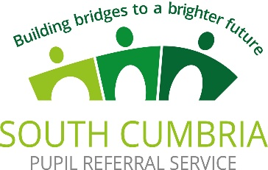

Mental health support for young people in Barrow is being developed to include school based support.
The planned new mental health support team will be based in secondary schools, Furness College, special schools and the Pupil Referral Service. This will be additional to the current support available. The role of the team will include:
- Individual Clinical Intervention
- Group Clinical Intervention
- Group low intensity Support
- Multi agency coordination
- School Staff training
- Behavioural intervention with parents
1: 1 interventions will cover:
- Anxiety
- Low Mood
- Self-Harm
- Lack of friendships
- Conduct problems
- In addition group interventions for
- Social problems
- Mild conduct problems
- Problems in maintaining concentration
- Learning readiness
- Managing ADHD
- Multi family groups based on social learning theory
Child & Parent workshops are planned to cover anxiety, self-harm, bullying, eating problems, behaviour problems, communication problems.

