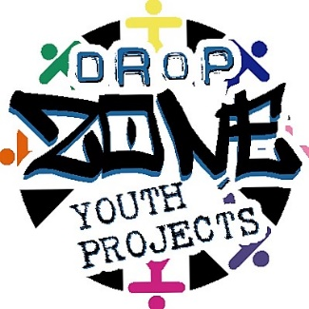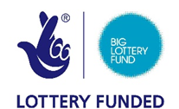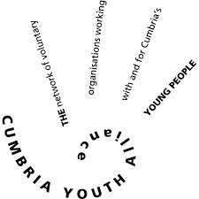

Young potential programme registration of interest
Dates: 22/07/209 – 30/08/2019

Name: | Contact email  Telephone No.
Please indicate if you are interested in the young potential programme at Drop Zone by deleting text adjacent | Yes/No

Cumbria Youth Alliance personal information form

Name: | Name of programme:  Young Potential programme
Personal Details
Home Address:  Post Code: | Home Telephone  Mobile:  Email address:
Date of Birth: | Do you have a disability:  If yes please provide details:
Emergency Contact Name:  Relationship:  Telephone Number: | Do you have any allergies?  If yes please give details:  Do you require travel expenses reimbursement:  If yes please provide cost: £
Do you have any medical conditions that we need to be made aware of?  If yes please give details: | Do you consider yourself to be physically fit?  Are you happy to engage in planned physical activities?
For session planning can you give us a brief description of your personal interests: | Are you happy for Cumbria Youth Alliance to take photos and share on social media whilst you are involve in the Young Potential programme: Yes/No

Please contact Cath Corkill on 01229812888 or via email at cathcorkill@yahoo.co.uk if you require any further information about the programme.

