Science Curriculum Policy

January 2025
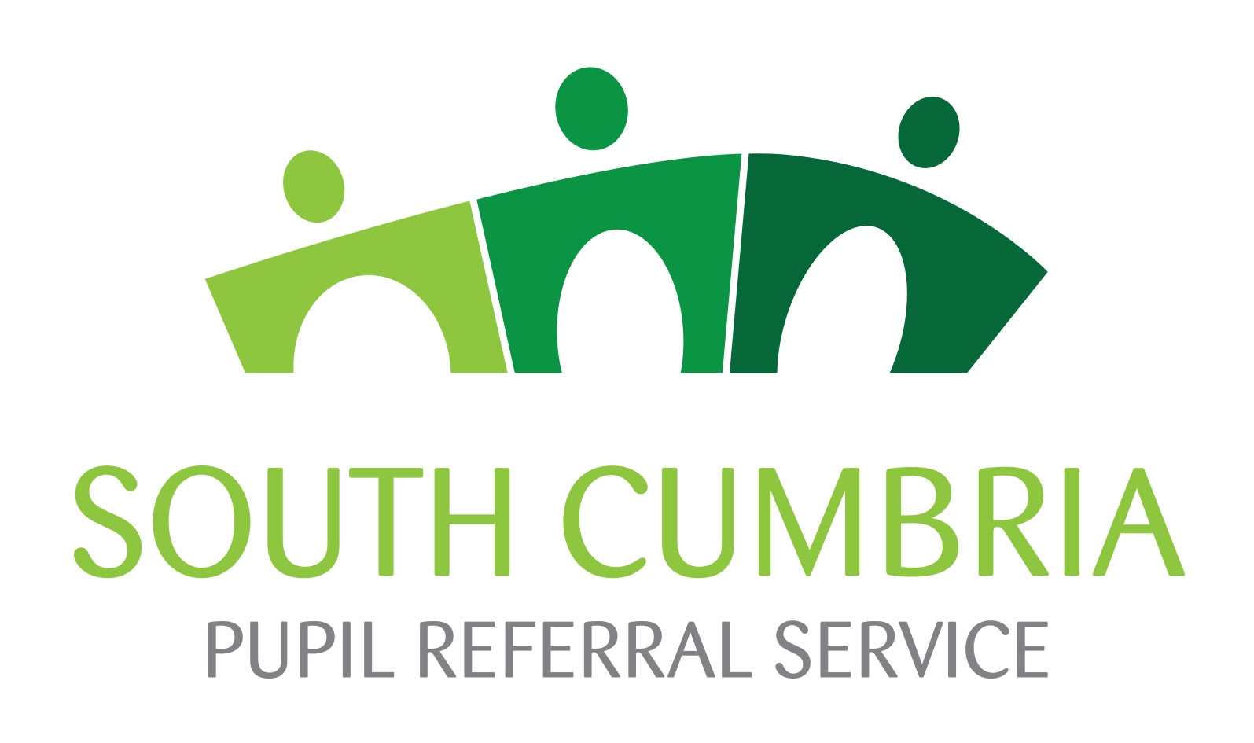

Introduction
Science is a fundamental subject that helps students make sense of the world around them. It encourages exploration, critical thinking, and problem-solving while developing the analytical and practical skills essential for everyday life and future opportunities. A strong science education not only builds knowledge but also fosters resilience, adaptability, and a lifelong appreciation for inquiry and discovery.

Science Vision & Intent
At Newbridge House, we are committed to delivering an inclusive and engaging science education that nurtures curiosity, builds confidence, and empowers all students to explore the world around them.
Our curriculum is designed to provide clear structure while remaining adaptable to meet the diverse needs of our students. By embedding STEM-focused learning, we enhance engagement, develop problem-solving and critical thinking skills, and cultivate the soft skills valued by employers. Through practical, hands-on experiences, we aim to break down barriers that may have previously limited students access to science in mainstream education and in doing so improve students’ self-belief and raise aspirations. Our approach aims to ensures that all learners, regardless of their starting points, achieve meaningful accreditation, from Entry Level Certificates to GCSE.
Through this, we equip students with scientific literacy, resilience, and a sense of achievement, preparing them for future learning, employment, and success beyond school.

Aims

- Foster a positive attitude towards science by making it accessible and engaging.
- Develop students’ problem-solving, critical thinking, data recording, and analysis skills.
- Maintain students access to an age-appropriate science pathway (either National Curriculum or GCSE) to support them for a return to mainstream education
- Deliver a differentiated curriculum that supports students individual needs to achieve qualifications from Entry Level Certificate (ELC) to GCSE.
- Provide a structured yet flexible learning experience that balances theoretical knowledge with hands-on application.
- Support literacy development and promote spiritual, moral, social, and cultural awareness.
- Actively promote British values and provide opportunities for careers education, information, advice, and guidance (CEIAG).

Curriculum Structure

We aim to provide students in all year groups with 3 science lessons a week. The science curriculum has been structured based on this to maximize engagement, retention, and academic progression.

Key Stage 2 & Key Stage 3:
- Students’ complete unit work on a rotation across Biology, Chemistry, and Physics, broadly aligned with the National Curriculum.
- A strong emphasis is placed on developing scientific inquiry skills such as critical thinking, problem-solving, and data analysis.
- Practical work is prioritized to enhance engagement and close learning gaps, ensuring students build confidence in science before progressing to Key Stage 4.

Years 9 & 10:
- The AQA Science Entry Level Certificate specification overlaps many of the fundamental topics covered in AQA GCSE Combined Science. Students therefore follow Entry Level Certificate (ELC) units, with differentiation in delivery to accommodate individual abilities (ranging from ELC up to GCSE level).
- Students in Year 9 and 10 will cover the same unit each term, one from each science specialism across the year. As part of each unit, they will complete a TDA (Teacher Designed Assessment) and ESA (Externally Set Assessment).
- Current Year 10 Cohort: Students should have completed 3 units by the end of year 10 and will therefore be entered for a single ELC certification.
- Future Cohorts (including current Year 9): Will follow a two-year rolling program covering six units across Year 9 and 10. This will allow students with us for two years to complete the double award ELC by the end of Year 10, while still accommodating for students who join us later as well as provide the opportunity for any student who returns to mainstream to achieve a qualification.
Year 11:
- Students will begin to be taught by specialisms (one lesson each per week in Biology, Chemistry, and Physics). This structure aids memory recall and mitigates the forgetting curve, ensuring students retain and apply knowledge effectively as they approach exams.
- Students will cover any remaining content necessary to access the AQA Combined Science Trilogy summer exams.
- Individual Cases: Where timetable constraints limit attendance, students may be entered for a single science GCSE (e.g., standalone Physics) with teaching tailored accordingly.

Science Teaching
Throughout all Key Stages, our science curriculum is guided by these foundational principles:

Developing Scientific Literacy

Scientific literacy is essential for enabling students to critically engage with an increasingly science-based world. We aim to ensure that our students can confidently interpret, communicate, and apply scientific knowledge in both academic and real-world contexts. Our approach aligns with disciplinary literacy in science (Shanahan & Shanahan, 2012), recognising that science has its own distinct ways of reading, writing, and speaking.
To develop these skills, we integrate:
- Explicit Vocabulary Instruction – Using strategies like the Frayer Model and etymology breakdowns to enhance scientific language acquisition.
- Reading in Science – Embedding comprehension strategies to help students analyse scientific texts and data
- Structured Scientific Writing – Teaching students to construct hypotheses, analyse results, and evaluate conclusions with scaffolds and model responses.
- Scientific Discussion & Oracy – Using dialogic teaching (Alexander, 2017) to develop reasoning, argumentation, and verbal communication skills.
- Data Interpretation & Numeracy – Ensuring students can critically evaluate graphs, tables, and experimental data to support evidence-based thinking.
By embedding these strategies throughout our curriculum, we break down barriers to science, support students with varying literacy needs, and equip them with the skills to confidently engage with science in education, work, and daily life.

Cross-Curricular Learning in Science

We recognise the importance of cross-curricular learning in developing a holistic understanding of science and its relevance to the wider world. Our science curriculum is designed to integrate knowledge and skills from other subjects, enhancing students' ability to make connections across different areas of learning. This approach not only deepens scientific understanding but also reinforces key transferable skills that students can apply in various contexts.
We achieve this by:
- Embedding Literacy Skills – Incorporates reading, writing, and communication tasks that support students’ development of disciplinary literacy as well as general literacy skills.
- Promoting Numeracy – Students are asked to apply mathematical skills such as data analysis, drawing graphs, and taking and recording measurements, fostering numeracy as a key competency in both science and everyday life.
- Connecting with Social Sciences – We explore the social, ethical, and environmental impacts of scientific discoveries (e.g., climate change, medical advancements, etc.), linking science to PSHE and Citizenship to help students engage with real-world issues.
- Supporting Personal Development and Wellbeing – Through links with PSHE, students discuss the impact of science on personal and social choices, such as drugs, healthy lifestyles, and sustainability.
- Developing Problem-Solving and Critical Thinking – STEM challenges and practical investigations help students strengthen critical thinking and problem-solving skills, which are applicable across all areas of learning and life.
This cross-curricular approach ensures that students not only gain scientific knowledge but also develop key skills and insights that support their overall academic and personal growth.

Adaptive Teaching and Differentiation in Science

Every student has unique learning needs and strengths. Our science curriculum is designed to be adaptive and differentiated to ensure that all students can achieve their potential. We use a variety of strategies to create a flexible learning environment to meet the needs of our students, particularly those with SEMH and learning challenges.
Our approach to differentiation includes:
- Differentiated Content – We tailor the content to match students’ abilities and learning styles. For example, students working at different levels may engage with simplified or more complex resources, depending on their understanding and confidence in the subject.
- Varied Teaching Methods – We use a combination of direct instruction, practical activities, visual aids, and technology to cater to different learning styles. Hands-on investigations, demonstrations, and multimedia resources help to engage students and make abstract scientific concepts more concrete.
- Scaffolded Support – We provide structured support, such as guided practice, step-by-step instructions, and tailored resources, to help students at different levels of readiness. This scaffolding ensures that all students are able to access challenging content while gradually building their independence.
- Flexible Pacing – Lessons are paced to meet individual needs, allowing students to process information comfortably and at their own speed, with additional support for those who require it.
- Use of Access Arrangements – We implement appropriate access arrangements, such as scribe support, additional time, and oral assessments, as our normal way of working to ensure students can demonstrate their learning effectively.
- Personalised Feedback and Reflection – Feedback is provided sensitively and constructively within lessons, ensuring students feel supported rather than criticised. Recognising that many of our students experience rejection sensitivity, we focus on delivering specific, actionable feedback in a way that builds confidence and encourages progress without overwhelming them.
Through these strategies, we ensure that all students are fully supported to succeed and can confidently progress in their scientific learning.

Assessment

At Newbridge House, we adopt an inclusive approach to assessment that reflects the diverse learning needs and barriers faced by our students. Understanding that students with SEMH challenges may encounter difficulties with traditional forms of assessment, we ensure that all students are provided with the necessary support to demonstrate their knowledge, understanding, and skills. Our assessment methods are designed to be flexible and to accommodate students' normal way of working, ensuring that assessments are accessible, fair, and meaningful.
Our assessment process includes:
- Formative Assessment Through Lesson and Unit Tasks – Regular, low-stakes tasks during lessons allow us to track ongoing progress and identify areas for development. These assessments are designed to be accessible to all learners, ensuring they can demonstrate understanding through a range of formats.
- Practical and Investigative Skills – Assessments focus on students' ability to engage in hands-on activities, practical investigations, and problem-solving tasks. These assessments are designed to help students develop essential scientific skills and are adapted to ensure that all students can participate and demonstrate their capabilities.
- Access Arrangements – In recognition of the unique needs of each student, we implement appropriate access arrangements where necessary. These may include the use of a scribe, additional time, or read aloud support, ensuring that all students are able to access assessments and fully demonstrate their understanding and skills.
- Personalised Tracking and Progress Monitoring – We use a flexible tracking system that allows us to follow each student’s progress, considering their individual barriers to learning. This system enables us to tailor interventions, adapt the pace of learning, and ensure that all students are supported to achieve success.
- Assessment for Progress, Not Just Achievement – We prioritise assessment for learning (AfL), aiming to provide students with regular feedback that helps them understand their strengths, identify areas for improvement, and develop strategies for overcoming challenges. We focus on growth mindset and support students to view mistakes as part of the learning process, which is vital for those with emotional or academic barriers.

Personal Development and British Values in Science

The science curriculum at Newbridge House fosters students’ personal development by promoting independence, collaboration, and resilience. Through practical scientific study, we develop students’ skills and character to prepare them for lifelong learning as responsible citizenship, while embedding Fundamental British Values.
We achieve this by:
- Encouraging Independence and Collaboration – Creating structured opportunities for students to collaborate on practical investigations, ensuring that roles are clear and that students support each other, to foster social and emotional development. As well as promote independent working.
- Promoting Responsibility for Learning – Metacognitive strategies help students reflect on their progress and take ownership of their learning.
- Fostering Respect and Tolerance – Students engage with diverse perspectives in scientific discussions when considering ethical issues and are taught to respect others' views.
- Enhancing Communication Skills – We support students in articulating ideas confidently, both verbally and in writing.
- Raising Awareness of Ethical, Social, and Environmental Issues – Topics like sustainability, medical ethics, and technological impact are explored to encourage informed decision-making.
- Embedding Health and Safety Awareness – Students learn about risk assessment, safety, and responsibilities in scientific and technical careers.
By embedding these principles into the science curriculum, we support students in becoming scientifically literate, responsible citizens who can make informed decisions about their own lives and the wider world.

Science and the Gatsby Benchmarks

A key focus is raising aspirations by connecting science education to future opportunities, including local STEM careers in Barrow-in-Furness. With major employers such as BAE Systems, Oxley, and Siemens offering careers in engineering, manufacturing, and technology, we aim to equip students with the skills and knowledge needed to access careers in these industries, fostering ambition and engagement in science.
The science curriculum actively contributes to meeting the Gatsby Benchmarks for good career guidance, ensuring students understand the relevance of science beyond the classroom.
We do this by:
- Addressing the Needs of Each Student (Benchmark 3): Tailoring science education to individual students’ aspirations and needs, ensuring all students are aware of potential career paths and qualifications that can support their goals.
- Linking Science to Careers (Benchmark 4): Regularly highlighting the relevance of scientific skills and knowledge to different career pathways, including engineering, healthcare, environmental science, and technology sectors.
- Encounters with Employers and Employees (Benchmark 5): Inviting guest speakers from STEM industries to discuss real-world applications of science and provide career insights, including opportunities specific to our local setting such as BAE Systems Ltd.
- Experience of Workplaces (Benchmark 6): Encouraging opportunities for students to visit scientific workplaces or engage in virtual work experiences related to STEM fields to explore science-related careers.
- Encounters with Further and Higher Education (Benchmark 7): Providing information about post-16 and higher education STEM opportunities, including vocational and academic routes.
By embedding the Gatsby Benchmarks and including links to careers in our science teaching, we help students see the relevance of science in their daily lives and future employment opportunities. This is especially important for students in our setting, as it can help break down barriers and widen their outlook on future possibilities.

Health and Safety

In all practical science activities, the use of equipment, chemicals, and materials will follow CLEAPS guidelines to ensure a safe and effective learning environment for all. Students will be provided with the necessary safety equipment, such as eye protection, gloves, and lab coats, as required for each activity. Safe practice will be consistently emphasised, and students will receive clear instructions on the correct handling of equipment and chemicals. Any improper use of equipment or failure to follow safety protocols will not be tolerated, and appropriate actions will be taken to ensure the well-being of all involved.

By prioritising safety, we aim to create an environment where students can develop their scientific skills confidently while maintaining a high standard of safety and responsibility.

This policy ensures that science at Newbridge House remains dynamic, inclusive, and engaging, fostering both academic success and a lifelong interest in scientific inquiry.

Charlotte Bower & Nick Jones – Specialist Teachers of Science
31/01/2025

References

Alexander, R. (2017) Towards Dialogic Teaching: Rethinking Classroom Talk. 5th edn. Cambridge: Dialogos.

Department for Education (DfE). (2014) Promoting fundamental British values as part of SMSC in schools: Departmental advice for maintained schools, academies, and free schools. Available at: https://www.gov.uk/government/publications/promoting-fundamental-british-values-through-smsc (Accessed: January 2025).

Education Endowment Foundation (EEF). (2018) Embedding formative assessment. Available at: https://educationendowmentfoundation.org.uk/projects-and-evaluation/projects/embedding-formative-assessment (Accessed: January 2025)

Education Endowment Foundation (EEF). (2022) Moving from ‘differentiation’ to ‘adaptive teaching’. Available at: https://educationendowmentfoundation.org.uk/news/moving-from-differentiation-to-adaptive-teaching (Accessed: January 2025)

Education Endowment Foundation (EEF). (2023) Assess, adjust, adapt – what does adaptive teaching mean to you? Available at: https://educationendowmentfoundation.org.uk/news/eef-blog-assess-adjust-adapt-what-does-adaptive-teaching-mean-to-you (Accessed: January 2025)

Gatsby Charitable Foundation. (2014) Good career guidance. Available at: https://www.gatsby.org.uk/education/focus-areas/good-career-guidance (Accessed: January 2025)

Ofsted. (2019) The education inspection framework: Education for all. Available at: https://www.gov.uk/government/publications/education-inspection-framework (Accessed: January 2025)

Shanahan, T. and Shanahan, C. (2012) 'What is disciplinary literacy and why does it matter?', Topics in Language Disorders, 32(1), pp. 7-18.

