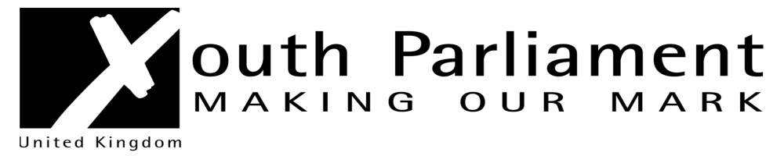
Westmorland and Furness UK Youth Parliament (UKYP) Elections 2024
Candidate Manifesto
Name: …………………………………………………………………………………….

Why do you want to become an MYP?

Tell us a bit about yourself? E.g., what music do you like? Hobbies and interests?

What is your unique selling point? What will make you stand out from other candidates?

Choose an issue that affects young people in Westmorland and Furness that you would like to campaign on or develop a project addressing:

Issue

Completed manifesto should be emailed to Lynne Murray Participation Officer on lynne.murray@westmorlandandfurness.gov.uk by 28th April 2024

