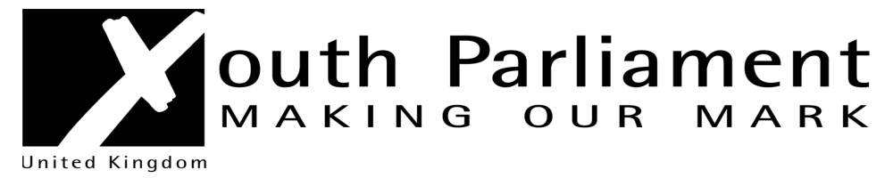
Westmorland and Furness UK Youth Parliament (UKYP) Elections 2024
Candidate Application Form

Name: …………………………………………………………………………………….

Mobile number: ………………………. Email: ……………………………….

Date of Birth: …………………………….

School/Centre: ……………………

Westmorland and Furness have a youth council open to young people aged 11-18 years. The youth council member works with school councils and other young people’s forums within their area to set local priorities and develop a local action plan.
Are you a member of Westmorland and Furness youth council? YES/NO
If NO, which town or village do you live in? ……..
If you are not a member of the Westmorland and Furness youth council the Participation Officer, Lynne Murray 079 008 588 87 will be in touch to get you involved in the youth council.
Please complete and return form to lynne.murray@westmorlandandfurness.gov.uk by 24th March 2024

