Work Experience

Newbridge House, Barrow in Furness – March 2023
- Opening Date
8th March 2023

- Closing Date
10th March 2023
- Interviews
14th March

- Start Date
17th March 2023
Every Friday 11.20am to 1pm
Duration 2 weeks
Certificate upon completion

INFORMATION
Morgan Sindall work experience programme aims to provide you with an insight into our role within the community and the challenges we face as a one of the largest Civil Engineering company in the UK.
During the two-week work experience, you’ll take part in interactive sessions and tasks to learn more about your own skills and how these relate to your CV’s. You will work on a hedgehog project and present the outcomes from it at the end of the programme.
Want A Career in Civil Engineering?
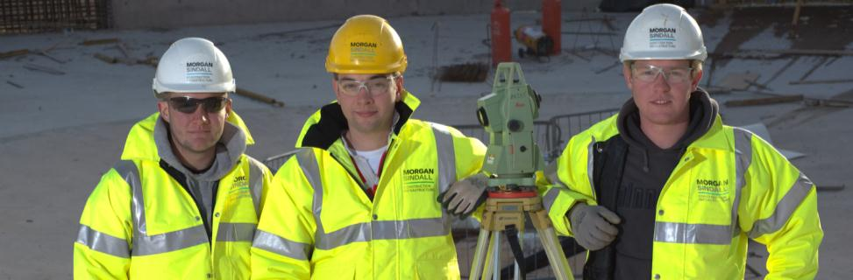
Our programme will give a slight insight into Civil Engineering but also a connection into other areas such as environmental.
This is open for students aged 14 and above from Newbridge House, Barrow in Furness.
To find out more about Morgan Sindall, take a look at our website (https://www.morgansindall.com/what-we-do/our-businesses/)
Candidate Information
Please write a covering letter about why you want to take part in this experience and also answer the question below.
Tell us something about your life so far that has made you feel that something is unachievable, but you are passionate about to prove you can achieve it.

