|  |  |  |  |
| --- | --- | --- | --- |
| |  |  | | --- | --- | | NEWBRIDGE NEWS  Issue 33: February 2022 | **C:\Users\chesworthks\AppData\Local\Microsoft\Windows\INetCache\Content.Outlook\RA0I4TQ2\Logo Square (Full Size) (002).jpg** |   **Welcome to Newbridge News – your monthly newsletter designed to keep you informed. All staff contributions are welcomed and will be included in the next edition. Please let me know if there is anything you would like to be included.** |  |

**Announcements / Good News!**

Happy New Year everyone and welcome back to 2022!

Congratulations to Jez and Dave who have been given a National Youth Anti-Violence Educational Award for the work we have done on the Knife Crime Project and Clive Knowles the National Lead for the Anti-Violence educational tour was full of praise for our service and its involvement.

Some nice news from over the Christmas holidays, Scott Bown popped the question to previous employee Sarah Bloor and she said yes! Congratulations and happy engagement to both of you! 

Congratulations also to past employee Helen Eastham and her partner Tom on the birth of baby George just before Christmas. 

Positive feedback from Settlebeck School that Amy Atkinson is doing very well there – the Headteacher commented that ‘it’s as if she has always been here and I am so pleased she came to us’ – thank you and well done everyone.

**Centre Developments**

There are monthly meetings held to discuss the AP development which will be based at Channelside and is currently due to be ready in Spring 2023 – more news when we have it!

**Diary Dates**

Half term = 14th – 18th February

Easter = 4th – 18th April

Inset Day (Abbey House) Tuesday 19th April

**Safeguarding**

If you have missed any of the training sessions on Wednesday or Thursday evenings regarding safeguarding topics, the [materials](../../../Safeguarding/Safeguarding%20training%20materials) are in the Safeguarding folder within icons on the system – please see Lisa, Jez, Kieran or Andy with any safeguarding queries

**Reminders**

Keep rooms ventilated, turn off electrical items at the end of the day (Particularly heaters) and ensure all surfaces are as clear as possible at the end of each day.

Always ensure you book the cars and any meetings rooms/pods etc. ahead of when you need them and make sure all meetings go on the calendar.

Please use the walkie talkie’s and / or ring home to check if the student has set off instead of waiting for students.

|  |  |
| --- | --- |
|  | Please complete the resource request form for any order over £100. Thanks |

**Exams**

Exam entry dates and deadlines have now been sent out to relevant staff if you can please make a note.

Invigilation Training information has also been sent out to all staff if you could please action when have time. Deadline is the 1st March.

**Website**

Please let Katy know if you have anything you would like to add to the school website.

**Careers**

National Apprenticeship week was a success in terms of students looking at their options post 16 and I’d like to thank everyone that held conversations and answered students questions on this. In the next month we have National Careers Week Monday-Saturday, 7-12 March 2022 which celebrates career guidance for young people, helping them to explore different career paths that may make sense for their interests. If you are able to support this in anyway please do come and see me.

Students will be visiting Furness College on March 25th and spending the morning at the college and have their lunch there.

Please continue to use Unifrog to log interactions on skills lessons, careers conversations and general well-being sessions. These are a massive support for students to recognise the skills that they are building in each area of their curriculum. Michaela

**Other**

Year 9 pupils have started their annual ‘Battle to Succeed’ enterprise project in partnership with Stollers. So far, they have raised £89 by making personalised Christmas Stockings for staff. We are continuing the project this year and are hoping to raise further funds for St Mary’s Hospice. Many thanks for all your support!

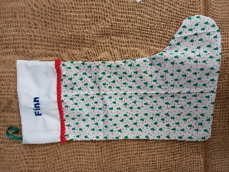 

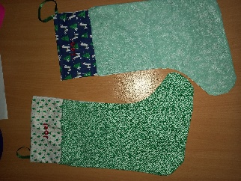 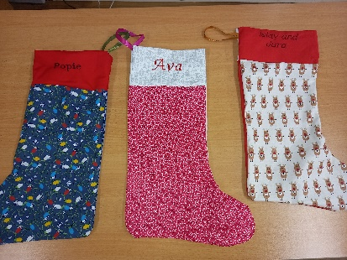

**Head teacher’s message**

Goodness what a long time it seems since the Christmas holidays – my appreciation for all the support provided to the team and to students particularly this term with our highest absences due to Covid. Please take some time this half term to look after your own wellbeing.

As we reach the mid-point of our school year (how did that happen?!) we know our numbers will be rising and we are seeing schools managing the impacts of Covid on their students resulting in referrals to HHTS and exclusions of students who have huge gaps in their school experience from the past two years – as always we will work together to identify and meet their needs. We chose to work in this setting and the challenges it brings but we recognise some (many) days are tough and the support of the team is so important – thank you.

**Management Committee**

Staffing & Finance meetings 26th April

Full Committee 17th May

If you are down to provide a report to one of the meetings, please ensure it has been checked by your line manager and is emailed to Leeann & Lisa by email at least 1 week before the meeting.

If there is anyone who would like to become a staff representative on the Full Management Committee please see Leeann or Lisa for more information about this opportunity. Thank you to Paul Stanway for the time and support he has given to the Committee over the years he has been a member.

Feedback from Committee members after our Full meeting on 8th February:

*That was a massively impressive meeting this evening.*

*In our Governance role I am really confident about every aspect of your work.*

*Whilst the LA do not always fully understand what the team achieve and our thoughts and ideas for the AP have been converted by the others responsible for the building, I know we will make the best of it.*

*I feel privileged to work with such a great team*

