South Cumbria Pupil Referral Service

Year 7 Catch-up Funding 2023/24

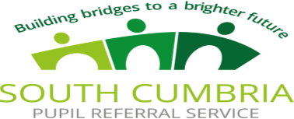

Number of pupils and funding received
Year 7 pupils on roll: | 0
Amount of Year 7 catch up funding received: | None
The literacy and numeracy catch-up premium provides schools with an additional funding for each year 7 pupil who did not achieve at least level 4 in reading and/or maths at the end of key stage 2.

Record of spending by item/project
Item/project | Cost
Total spend

Summary of Impact
Objectives in spending: | There are no current students in year 7 and last year there were no Key stage 2 students in year 6 to move into year 7. Should any eligible year 7 students be referred to us or be permanently excluded we will check with the school how this funding was being spent alongside our initial assessment of need.
Outcomes to date:




